



**CS4001NI Programming**

**30% Individual Coursework**

**2022-23: Spring**

**Student Name: Sameer Parajuli**

**London Met ID: 22068075**

**College ID: NP01CP4A220388**

**Group: L1C16**

**Assignment Due Date: Wednesday, May 10, 2023**

**Assignment Submission Date: Wednesday, May 10, 2023**

*I confirm that I understand my coursework needs to be submitted online via MySecondTeacher under the relevant module page before the deadline in order for my assignment to be accepted and marked. I am fully aware that late submissions will be treated as non-submission and a marks of zero will be awarded.*

**Table of Contents**

**1. Introduction 1**

**2. Class Diagram 2**

**2.1 Class Diagram of Bank Card 2**

**2.2 Class Diagram of Debit Card 3**

**2.3 Class Diagram of Credit Card 4**

**2.4 class diagram of BankGUI 5**

**2.5 complete diagram of the overall class diagram 6**

**3. Pseudocode 7**

**3.1 Pseudocode of BankGUI 7**

**4. Method description 19**

**4.1 Method description of BankGUI class 19**

**5. Testing 22**

**5.1 Test 1: Add in the values in the debit card with add button and withdraw balance with withdraw button and displaying in terminal 22**

**5.2 Test 2: Add the values in the credit card with add button, set credit with set button, cancel credit card with cancel button and display values in the terminal. 25**

**5.3 Test 3: Appropriate dialog boxes appear when unsuitable values are entered for the Card ID 29**

**5.4 Test 4: Display the details of Debit Card and Credit Card classes. 32**

**6. Error detection and correction 33**

**6.1 Syntax error and correction 33**

**6.2 Semantic error and correction 34**

**6.3 Logical error and correction 35**

**7. Conclusion 36**

**8. Appendix 37**

**Table of Figures**

**Figure 1:Class Diagram of Bank Card** 2

**Figure 2:Class Diagram of Debit Card** 3

**Figure 3:Class Diagram of Credit Card** 4

**Figure 4:Class Diagram of BankGUI** 5

**Figure 5: Overall class diagram** 6

**Figure 6: Screenshot of the value added in debit card** 23

**Figure 7: Screenshot the amount withdrawn in debit card** 24

**Figure 8: Screenshot of displaying the values** 24

**Figure 9: Screenshot of the value added in credit card** 26

**Figure 10: Screenshot of the values added to set the credit limit** 27

**Figure 11: Screenshot of values displayed in terminal after setting the credit limit** 27

**Figure 12: Screen shot of the credit card being cancelled** 28

**Figure 13: Screenshot of the values displayed in the terminal after cancelling the credit card** 29

**Figure 14: Screenshot of error dialog while input string instead of integer in card id on debit card** 31

**Figure 15: Screenshot of error dialog while input wrong card id while withdrawing** 31

**Figure 16: Screenshot of error dialog while input string instead of integer in card id on credit card** 32

**Figure 17: Screenshot of error dialog while input wrong card id while setting credit limit** 32

**Figure 18: Running the program through command prompt** 34

**Figure 19: Syntax error** 35

**Figure 20: Syntax error corrected** 35

**Figure 21: Semantic Error** 36

**Figure 22: Semantic error correction** 36

**Figure 23: Logical error** 37

**Figure 24: Logical error correction** 37

**Table of Tables**

**Table 1:Add values, withdraw and display in debit card** 22

**Table 2: To add values, set credit limit, cancel credit card and display the values in the terminal** 25

**Table 3:Inspecting dialog box appear when unsuitable values are input in card ID.** 29

**Table 4: Inspecting the program if it run through command prompt** 32

# 1. Introduction

This report summarizes the course material on implementing a Java Graphical User Interface (GUI). The course's objective was to give students practical experience in utilizing Java, a popular programming language for creating desktop programs, to design and create a GUI. Today's software development requires the use of GUIs since they provide a user-friendly and interactive software interface.

A functioning GUI application had to be created for the coursework. This report describes the methods utilized to implement the GUI many features as well as the procedures taken to develop it.

We acquired knowledge of the essentials of Java GUI programming, such as user input validation, layout management, and event handling, throughout the course work. We also looked at various libraries and tools that can be utilized to streamline GUI creation.

Overall, the coursework provided useful practice in building Java GUIs and laid the groundwork for future development initiatives. The design, implementation, and evaluation of the GUI application created during the coursework are described in the parts that follow.

# 2. Class Diagram

## 2.1 Class Diagram of Bank Card

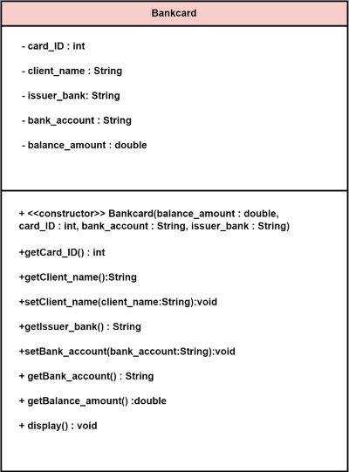

**Figure 1:Class Diagram of Bank Card**

## 2.2 Class Diagram of Debit Card

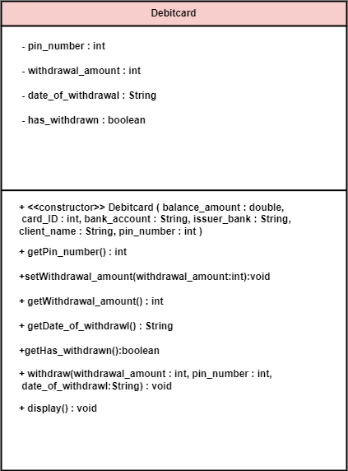

**Figure 2:Class Diagram of Debit Card**

## 2.3 Class Diagram of Credit Card

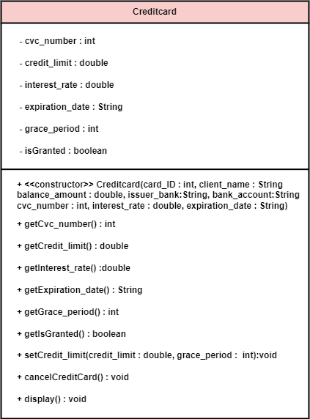

**Figure 3:Class Diagram of Credit Card**

## 

## 2.4 class diagram of BankGUI

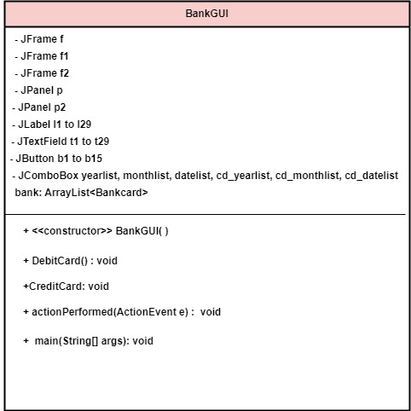

**Figure 4:Class Diagram of BankGUI**

## 2.5 complete diagram of the overall class diagram

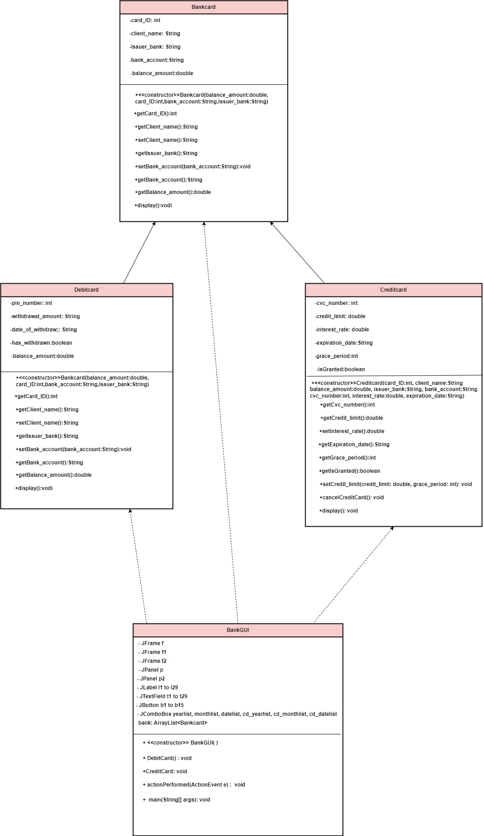

**Figure 5: Overall class diagram**

# 3. Pseudocode

## 3.1 Pseudocode of BankGUI

**IMPORT JAVA.AWT**

**IMPORT JAVAX.SWING**

**IMPORT JAVA.AWT.EVENT**

**IMPORT JAVA.UTIL.ARRAYLIST**

**CREATE** a class BankGUI which extends Frame and implements ActionListener

**DO**

**DECLARE** JFrame

**DECLARE** JPanel

**DECLARE** JLabel

**DECLARE** JTextField

**DELCARE** JComboBox

**DECLARE** ArrayList of Bankcard

**CREATE** constructor BankGUI

**DO**

**ASSIGN** attribute f with JFrame

**ASSIGN** attribute p with JPanel

**ADD** p in f

**ASSIGN** JButtons

**ADD** JButton debit card, credit card

**ADD** b1, b2 in ActionListener

**SET** layout in f as null

**SET** layout in p as null

**SET** size of p

**SET** size of f

**SET** visible as true in f

**SET** visible as true in p

**SET** title as BankGUI in f

**SET** default Close Operation in f

**END DO**

**CREATE PUBLIC VOID** method Debit Card

**DO**

**ASSIGN** attribute f1 in JFrame

**ASSIGN** attribute p1 in JPanel

**ADD** panel in frame

**ADD** JLabel add to debit card, client name, issuer bank, cardi id, bank account,

balance amount, pin number, withdraw, card id, withdrawl amount, date of withdrawl,

pin number

**ADD** JTextField t1, t2, t3, t4, t5, t6, t7, t8, t9

**ADD** JComboBox year list, month list, date list

**ADD** JButton add to debit card, display, withdraw, clear, go back

**REGISTER** action listener onb3, b4, b5, b6, b7

**SET** layout in p1 as null

**SET** size of f1

**SET** visible as true in f1

**SET** title as DebitGUI in f1

**SET** default Close Operation in f1

**END DO**

**CREATE PUBLIC VOID** method Credit Card

**DO**

**ASSIGN** attribute f2 in JFrame

**ASSIGN** attribute p2 in JPanel

**ADD** panel in frame

**ADD** JLabel add to credit card, client name, issuer bank, card id, bank account,

Balance amount, cvc number, set credit limit, card id, credit limit, grace period,

Interest rate, expiration date, cancel credit card, card id

**ADD** JTextField t15, t16, t17, t18, t19, t20, t21, t22, t23, t24, t25

**ADD** JComboBox cd year list, cd month list, cd date list

**ADD** JButton add to credit card, display, go back, cancel, set, clear

**REGISTER** action listener onb8, b9, b10, b11, b12, b13

**SET** layout in p2 as null

**SET** size of f2

**SET** visible as true in f2

**SET** title as DebitGUI in f2

**SET** default Close Operation in f2

**END DO**

**CREATE PUBLIC VOID** method actionPerformed with parameter ActionEvent e

**DO**

**USE TRY** exception

**IF** event source object is equal to b1

**CALL CLASS** Debitcard

**SET** visible as false in f

**SET** visible as true in f1

**ELSE IF** event source object is equal to b2

**CALL CLASS** Creditcard

**SET** visible as false in f

**SET** visible as true in f2

**ELSE IF** event source object is equal to b7

**CALL** constructor

**SET** visible as false in f1

**ELSE IF** event source object is equal to b10

**CALL** constructor

**SET** visible as false in f2

**ELSE IF** event source object is equal to b8

**USE TRY** exception

**SET** the variable client name equal to the text entered in the GUI component with the

name t16

**SET** the variable issuer name equal to the text entered in the GUI component with

the name t17

**SET** the variable card id equal to the text entered in the GUI component with

the name t18

**SET** the variable bank account equal to the text entered in the GUI component with

the name t19

**SET** the variable cvc number equal to the text entered in the GUI component with

the name t20

**ASSIGN** the selected item of cd year list to variable cd year

**ASSIGN** the selected item of cd date list to variable cd date

**ASSIGN** the selected item of cd month list to variable cd month

**CREATE OBJECT** of credit card class with parameter card id, client name, balance

Amount, issuer bank, bank account, cvc number, interest rate, expiration date

**ADD** **OBJECT** of credit card on arraylist of bank card

**DISPLAY SUCCESS MESSAGE DIALOG** inf2

**PRINT** added

**END TRY** exception

**USE CATCH EXCEPTION** with parameter number format exception err

**PRINT** error

**DISPLAY ERROR MESSAGE DIALOG** inf2

**END CATCH** exception

**ELSE IF** event source object is equal to b3

**USE TRY** exception

**SET** the variable client name equal to the text entered in the GUI component with the

name t1

**SET** the variable issuer name equal to the text entered in the GUI component with

the name t2

**SET** the variable card id equal to the text entered in the GUI component with

the name t3

**SET** the variable bank account equal to the text entered in the GUI component with

the name t4

**SET** the variable balance amount equal to the text entered in the GUI component with

the name t5

**SET** the variable pin number equal to the text entered in the GUI component with

the name t6

**CREATE OBJECT** of debit card class with parameter balance amount, card id, bank account, issuer bank, client name, pin number

**ADD** **OBJECT** of debit card on arraylist of bank card

**DISPLAY SUCCESS MESSAGE DIALOG** inf1

**PRINT** added

**END TRY** exception

**USE CATCH EXCEPTION** with parameter number format exception err

**PRINT** error

**DISPLAY ERROR MESSAGE DIALOG** inf1

**END CATCH** exception

**ELSE IF** event source object is equal to b6

**SET** to the text entered in the GUI component with the name t1 empty

**SET** to the text entered in the GUI component with the name t2 empty

**SET** to the text entered in the GUI component with the name t3 empty

**SET** to the text entered in the GUI component with the name t4 empty

**SET** to the text entered in the GUI component with the name t5 empty

**SET** to the text entered in the GUI component with the name t6 empty

**SET** to the text entered in the GUI component with the name t7 empty

**SET** to the text entered in the GUI component with the name t8 empty

**SET** to the text entered in the GUI component with the name t9 empty

**ELSE IF** event source object is equal to b13

**SET** to the text entered in the GUI component with the name t15 empty

**SET** to the text entered in the GUI component with the name t16 empty

**SET** to the text entered in the GUI component with the name t17 empty

**SET** to the text entered in the GUI component with the name t18 empty

**SET** to the text entered in the GUI component with the name t19 empty

**SET** to the text entered in the GUI component with the name t20 empty

**SET** to the text entered in the GUI component with the name t21 empty

**SET** to the text entered in the GUI component with the name t22 empty

**SET** to the text entered in the GUI component with the name t23 empty

**SET** to the text entered in the GUI component with the name t24 empty

**SET** to the text entered in the GUI component with the name t25 empty

**ELSE IF** event source object is equal to b5

**USE TRY** exception

**SET** the variable card id equal to the text entered in the GUI component with

the name t7

**SET** the withdrawl amount equal to the text entered in the GUI component with

the name t8

**SET** the variable pin number equal to the text entered in the GUI component with

the name t9

**ASSIGN** the selected item of year list to variable deb year

**ASSIGN** the selected item of date list to variable deb date

**ASSIGN** the selected item of month list to variable deb month

**ADD** deb year, deb month, deb year to variable date of withdrawl

**USE FOR** loop on ArrayList creating **OBJECT** of Bankcard class

**IF OBJECT** is instance of debit card class

**DOWNCAST** debit card

**IF** card id is equal to card id

**IF** pin number is equal to pin number

**IF** withdrawl amount is less than or equal to balance amount

**CALL** withdraw method

**DISPLAY SUCCESS MESSAGE DIALOG** inf1

**END IF**

**ELSE**

**DISPLAY ERROR MESSAGE DIALOG** inf1

**END IF**

**ELSE**

**DISPLAY ERROR MESSAGE DIALOG** inf1

**END IF**

**ELSE**

**DISPLAY ERROR MESSAGE DIALOG** inf1

**END IF**

**END LOOP**

**END TRY** exception

**USE CATCH EXCEPTION** with parameter number format exception err

**PRINT** error

**END CATCH** exception

**ELSE IF** event source object is equal to b12

**USE TRY** exception

**SET** the variable card id equal to the text entered in the GUI component with

the name t22

**SET** the variable credit limit equal to the text entered in the GUI component with

the name t23

**SET** the variable grace period equal to the text entered in the GUI component with

the name t25

**USE FOR** loop on ArrayList creating **OBJECT** of Bankcard class

**IF OBJECT** is instance of Creditcard class

**DOWNCAST** Creditcard

**IF** card id is equal to card id

**IF** credit limit is less than or equal to 2.5 times balance amount

**CALL** credit limit method

**DISPLAY SUCCESS MESSAGE DIALOG** inf2

**END IF**

**ELSE**

**DISPLAY ERROR MESSAGE DIALOG** inf2

**END IF**

**ELSE**

**DISPLAY ERROR MESSAGE DIALOG** inf2

**END IF**

**END LOOP**

**END TRY** exception

**USE CATCH EXCEPTION** with parameter number format exception err

**PRINT** error

**END CATCH** exception

**ELSE IF** event source object is equal to b11

**USE TRY** exception

**SET** the variable card id equal to the text entered in the GUI component with

the name t22

**USE FOR** loop on ArrayList creating **OBJECT** of Bankcard class

**IF OBJECT** is instance of Creditcard class

**DOWNCAST** Creditcard

**IF** card id is equal to card id

**CALL** cancel credit card method

**DISPLAY SUCCESS MESSAGE DIALOG** inf2

**PRINT** canceled

**END IF**

**ELSE**

**DISPLAY ERROR MESSAGE DIALOG** inf2

**END IF**

**END LOOP**

**END TRY** exception

**USE CATCH EXCEPTION** with parameter number format exception err

**PRINT** error

**END CATCH** exception

**ELSE IF** event source object is equal to b9

**USE FOR** loop on ArrayList creating **OBJECT** of Bankcard class

**IF OBJECT** is instance of Creditcard class

**DOWNCAST** Creditcard

**CALL** display method

**END IF**

**END LOOP**

**ELSE IF** event source object is equal to b4

**USE FOR** loop on ArrayList creating **OBJECT** of Bankcard class

**IF OBJECT** is instance of Debitcard class

**DOWNCAST** Debitcard

**CALL** display method

**END IF**

**END LOOP**

**CREATE** main method

**CALL** constructor

**END DO**

# 4. Method description

## 4.1 Method description of BankGUI class

**DebitCard ():** This is a void method which creates JFrame and JPanel object and add the JPanel to the JFrame. It also adds several JLabels, JTextFields, JComboBox, and JButton to the JPanel. The JLabels display various text labels, such as “Client Name”, “Balance Amount”, “Pin number”, etc. The JTextFields allows the user to input data similarly the JComboBox allows the user to select year, month, date. While the JButton performs various actions such as adding a debit card, withdrawing, clearing, going back.

Finally, the method set the size of the JFrame, sets the title, makes it visible and sets the default close operation.

Overall, the method creates a GUI for managing debit card, allowing the user to add, and perform transactions.

**CreditCard ():** This is a void method which creates JFrame and JPanel object and add the JPanel to the JFrame. It also adds several JLabels, JTextFields, JComboBox, and JButton to the JPanel. The JLabels display various text labels, such as “Client Name”, “Balance Amount”, “CVC number”, etc. The JTextFields allows the user to input data similarly the JComboBox allows the user to select year, month, date. While the JButton performs various actions such as adding a credit card, setting credit limit, clearing, going back and cancelling.

Finally, the method set the size of the JFrame, sets the title, makes it visible and sets the default close operation.

Overall, the method creates a GUI for managing credit card, allowing the user to add, and perform transactions.

**actionPerformed(ActionEvent e):** The Java Swing action listener interface is being implemented in this code for a graphical user interface (GUI). When a user interacts with a button or text field on the GUI, the actionPerformed method is invoked. The method then executes an action based on the event's source, which is discovered using the ActionEvent object's getSource method.

Several if-else lines in the code check the event's source before carrying out the appropriate action. Here is a quick summary of what each if-else block accomplishes:

* The first block determines whether a button labelled b1 is the event's source. If so, it invokes the DebitCard function, hides one GUI frame (f), and displays another (f1).
* The second block determines whether a button labelled b2 is the event's source. If so, it invokes the CreditCard function, hides the first GUI frame (f), and displays the second (f2).
* The third block determines whether the b7 button is the event's source. If so, a new instance of the BankGUI class is created and one GUI frame (f1) is hidden.
* The fourth block determines whether the b10 button is the event’s source. If so, a new instance of the BankGUI class is aerated and one GUI frame(f2) is hidden.
* The fifth block determines whether the b8 button is the event's source. If so, it tries to read various text fields and uses the data to generate a new instance of a Creditcard object. After that, if the procedure was successful, it adds the new Creditcard object to array list called bank and displays a message window.
* The sixth block determines whether a button labelled b3 is the event's source. If so, it tries to read multiple text fields and uses the data to generate a new instance of a Debitcard object. The new Debitcard object is then added to the array list named bank, and if the operation was successful, a message dialog is displayed.
* The seventh block determines if the button designated as b6 is the event's source. If so, multiple text fields are cleared.
* The eighth block determines if the b13 button is the event's source. If so, multiple text fields are cleared.
* The ninth block determines if the button labelled "b5" is the event's source. If so, it attempts to read numerous text fields before taking money out of a bank object named Debitcard in the array list. If the procedure was successful, it displays a message dialog with the pertinent information; otherwise, it displays an error window.
* The tenth block determines whether a button labelled b12 is the event's source. If so, it makes multiple attempts to read text fields before setting the credit limit of a Creditcard object in the array list referred to as bank. Message dialog is displayed if the procedure was successful.
* The eleventh block determines whether a button labelled b11 is the event’s source. If so, it makes multiple attempts to read text field before cancelling the credit card of a Creditcard object in the array list referred to as bank. Message dialogue is displayed procedure was successful
* The 12th block determines whether a button labelled b9 is the event’s source. If so, it displays the data.
* The last block determines whether a button labelled b4 is the event’s source. If so, it displays the data.

**Main method():** The "new" keyword is used inside the main method to create a new BankGUI class object and run its constructor. This indicates that the constructor of the BankGUI class is being called as well as the class being instantiated.

A graphical user interface for a banking application is likely created by this code, which overall initializes a BankGUI object.

# 5. Testing

## 5.1 Test 1: Add in the values in the debit card with add button and withdraw balance with withdraw button and displaying in terminal

|  |  |
| --- | --- |
| Test NO | 1 |
| Objective | To Add in the values in the debit card with add button and withdraw balance with withdraw button and displaying in terminal. |
| Action | The following values is added.  Client name: Sameer  Issuer bank: Mega  Card id: 55  Bank account: Saving  Balance Amount: 50000  Pin number: 12345  Adding values to withdraw.  Card id: 55  Withdraw Amount: 10000  Date of withdrawl: 2023-jan-1  Pin number: 12345  Displaying in terminal. |
| Expected result | The values should be added by clicking add to debit card button, amount should be withdrawn by clicking withdraw button and display in terminal by clicking display button. |
| Actual result | The values is added, amount has been withdrawn and the results are displayed in the terminal. |
| Conclusion | Result successful |

**Table 1:Add values, withdraw and display in debit card**

**OUTPUT**

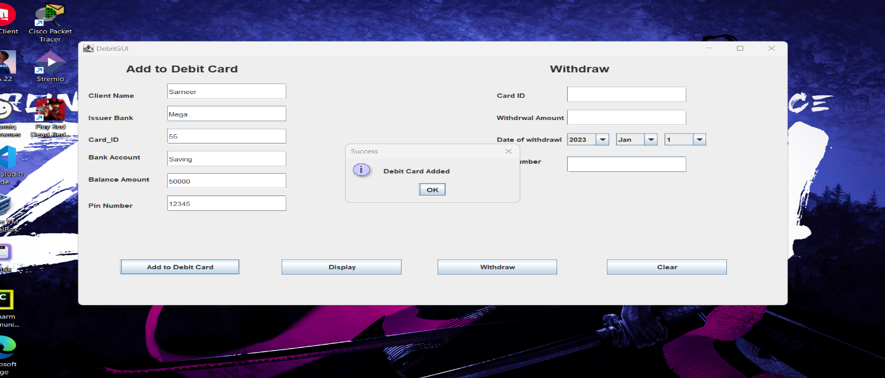

**Figure 6: Screenshot of the value added in debit card**

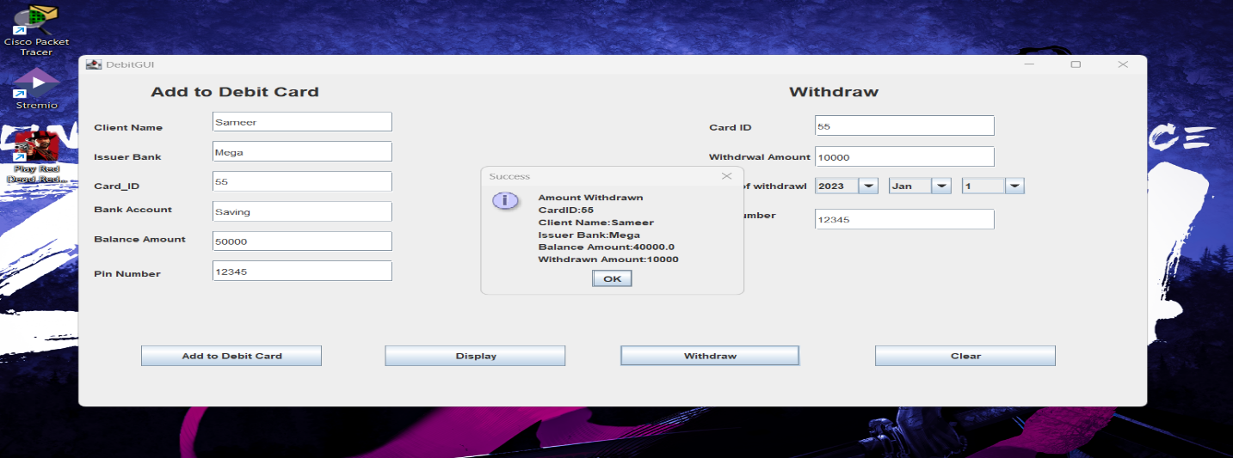

**Figure 7: Screenshot the amount withdrawn in debit card**

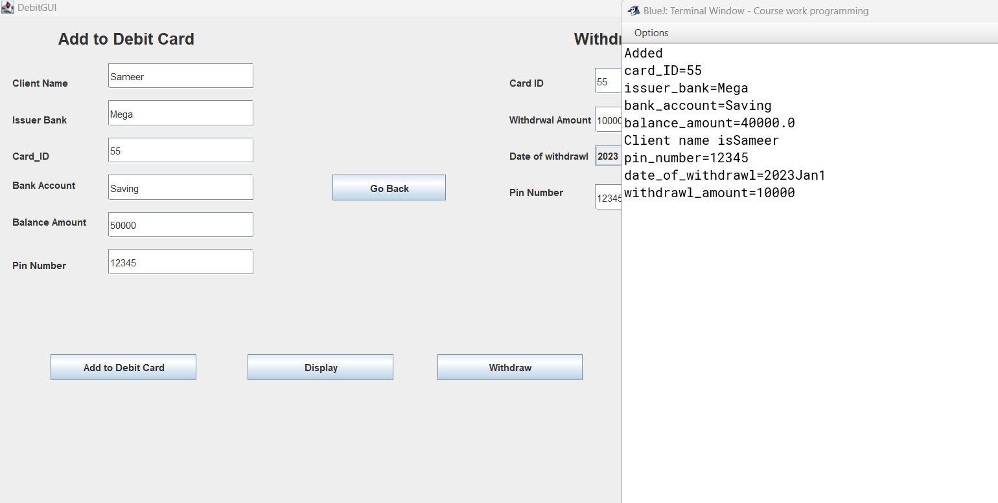

**Figure 8: Screenshot of displaying the values**

# 5.2 Test 2: Add the values in the credit card with add button, set credit with set button, cancel credit card with cancel button and display values in the terminal.

|  |  |
| --- | --- |
| Test NO | 2 |
| Objective | To Add in the values in the credit card with add button, set credit with set button, cancel credit card with cancel button and display the values in the terminal. |
| Action | The following values is added  Client name: Sameer  Issuer Bank: Mega  Card id: 55  Bank account: Saving  Balance Amount: 50000  CVC number: 123  Interest rate: 6%  Expiration date: 2023-jan-1  Adding values to set credit limit  Card id: 55  Credit limit: 20000  Grace period: 26  Adding values to cancel credit card  Card id: 55  Displaying by setting credit limit  Card id: 55  Issuer bank: mega  Bank account: saving  Balance amount: 50000  Client name: sameer  CVC number: 123  Credit limit: 20000  Interest rate: 6  Expiration date: 2023-Jan-1  isGranted = true  Displaying after cancelling the credit card  Card ID: 55  Issuer bank: Mega  Bank account: Saving  Balance amount: 50000.0  Client name: Sameer  CVC number: 0  Credit limit: 0.0  Interest rate: 0.0  Expiration date: 2023-Jan-1  isGranted: false  grace period=0 |
| Expected result | To add values with add to credit card button, set credit limit by clicking set button, cancel credit card by clicking cancel button  and display the values in terminal after setting credit limit and cancelling the card. |
| Actual result | Values added, credit limit set, credit card cancel and values displayed in the terminal by clicking their specific buttons. |
| Conclusion | Successful |

**Table 2: To add values, set credit limit, cancel credit card and display the values in the terminal**

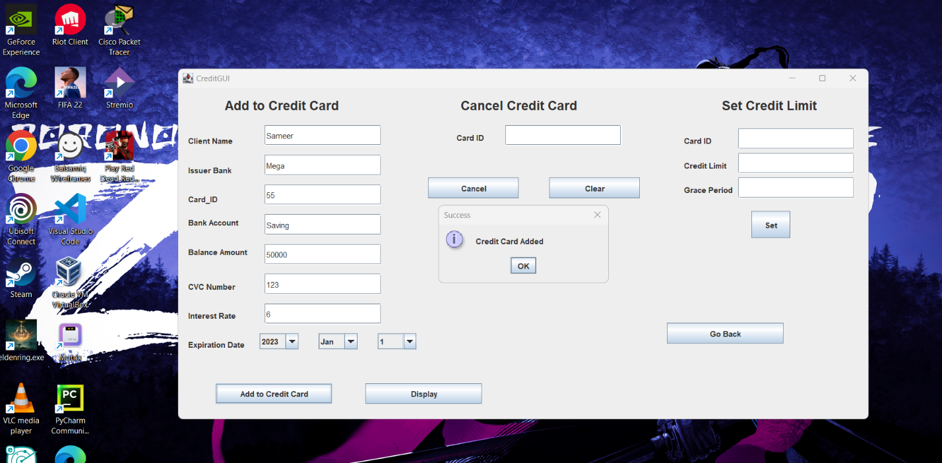

**Figure 9: Screenshot of the value added in credit card**

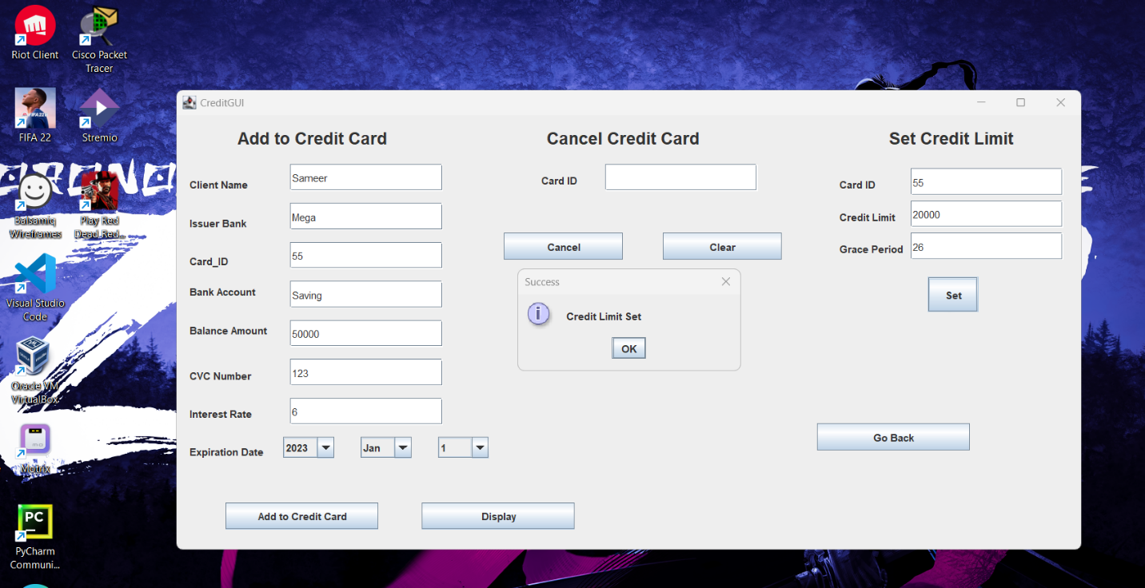

**Figure 10: Screenshot of the values added to set the credit limit**

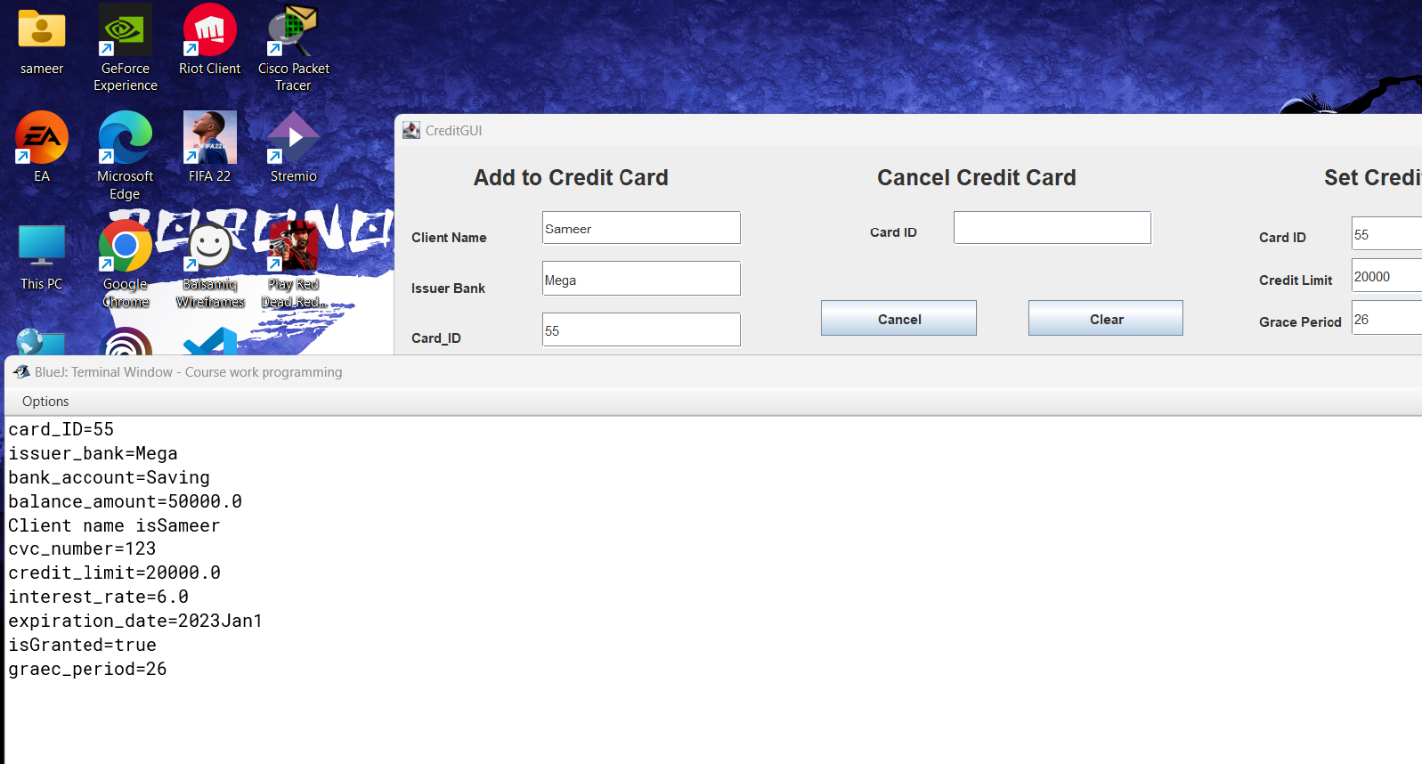

**Figure 11: Screenshot of values displayed in terminal after setting the credit limit**

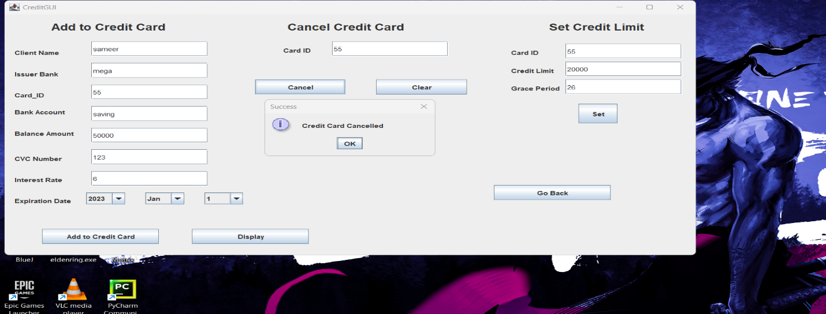

**Figure 12: Screen shot of the credit card being cancelled**

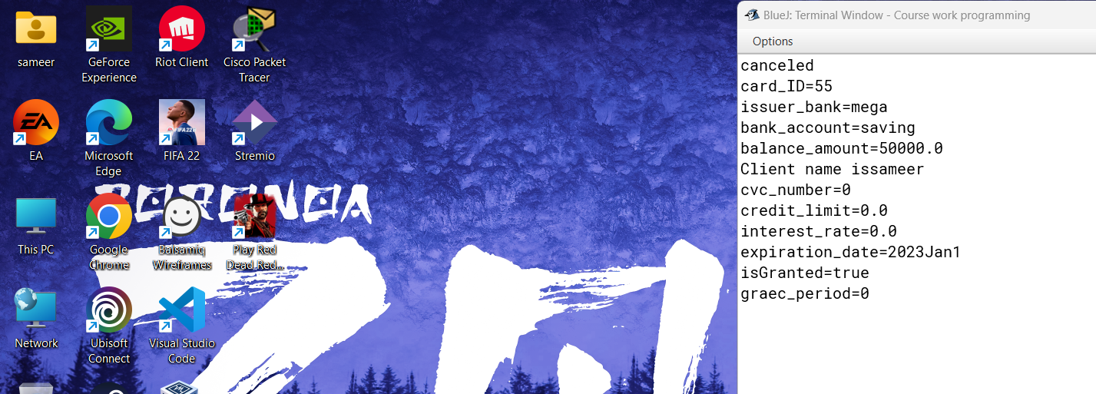

**Figure 13: Screenshot of the values displayed in the terminal after cancelling the credit card**

# 5.3 Test 3: Appropriate dialog boxes appear when unsuitable values are entered for the Card ID

|  |  |
| --- | --- |
| Test NO | 3 |
| Objective | To Inspect dialog box appear when unsuitable values are entered for the card id |
| Action | Card ID is input as string variable while using add button.  Card ID does not match to added card ID while withdrawing and set credit limit. |
| Expected result | The error dialog box should appear. |
| Result | The error dialog box appeared. |
| Conclusion | Successful |

**Table 3:Inspecting dialog box appear when unsuitable values are input in card ID.**

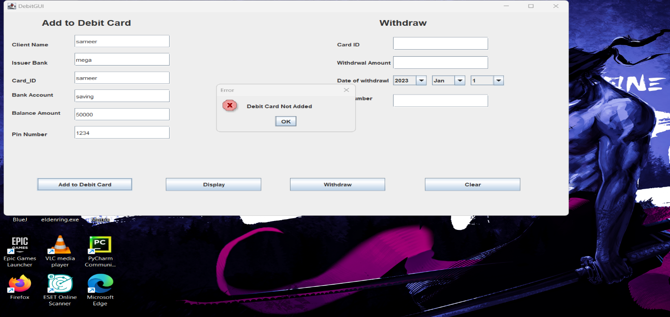

**Figure 14: Screenshot of error dialog while input string instead of integer in card id on debit card**

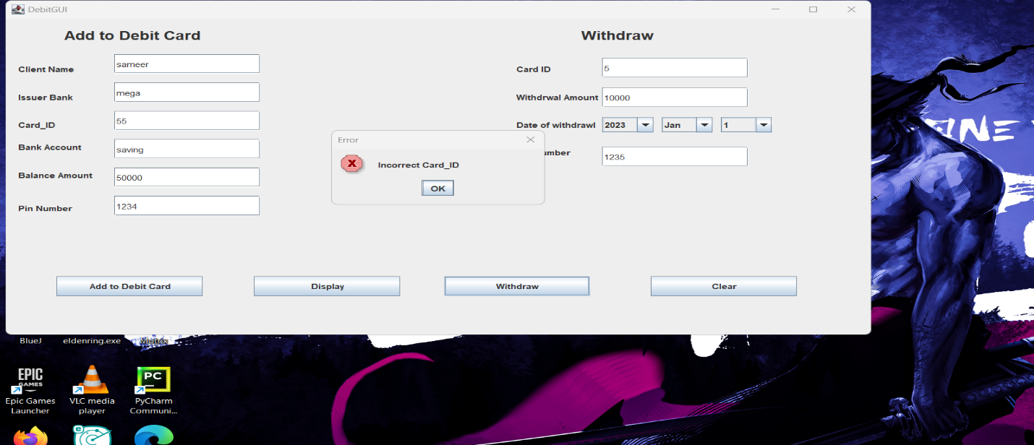

**Figure 15: Screenshot of error dialog while input wrong card id while withdrawing**

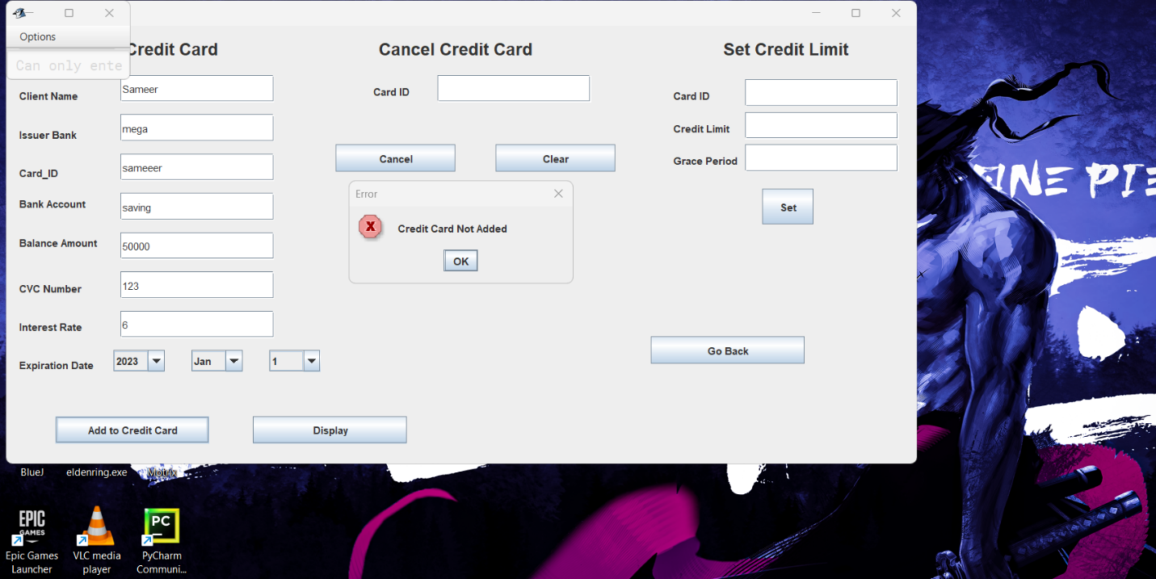

**Figure 16: Screenshot of error dialog while input string instead of integer in card id on credit card**

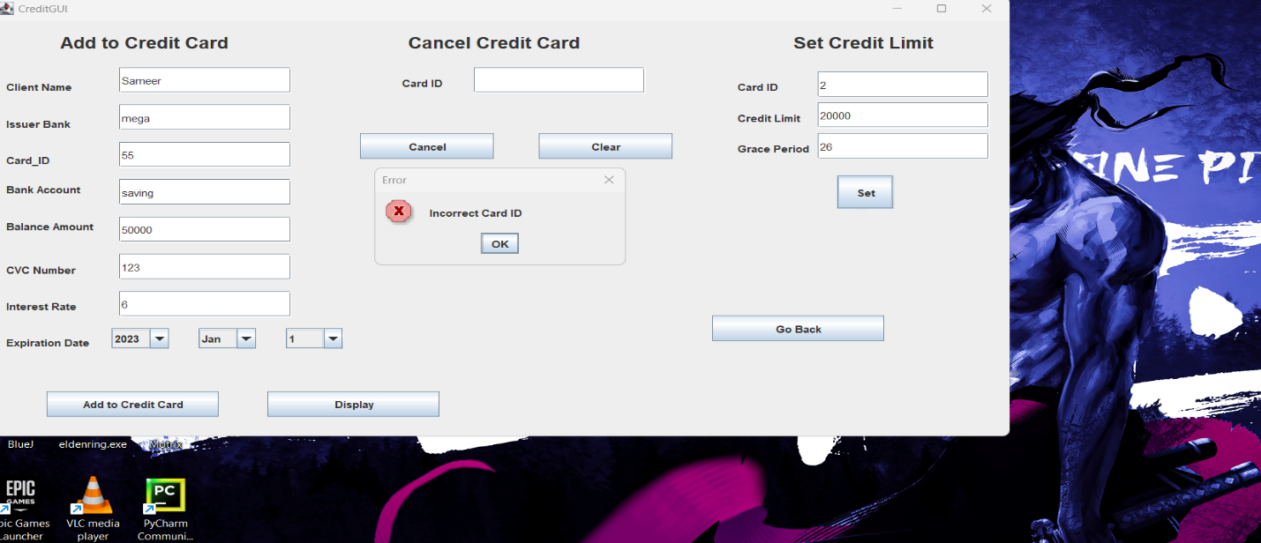

**Figure 17: Screenshot of error dialog while input wrong card id while setting credit limit**

# 5.3 Test 4: The program can be compiled and run using the command prompt.

|  |  |
| --- | --- |
| Test NO | **4** |
| Objective | To compile and run the program using command prompt |
| Action | Going into the program location through command prompt.  Compiling the program by using command javac BankGUI.java  Run the programming using command BankGUI.java |
| Expected result | The program should be compiled and run |
| Result | The program compiled and rm |
| Conclusion | Successful |

**Table 4: Inspecting the program if it run through command prompt**

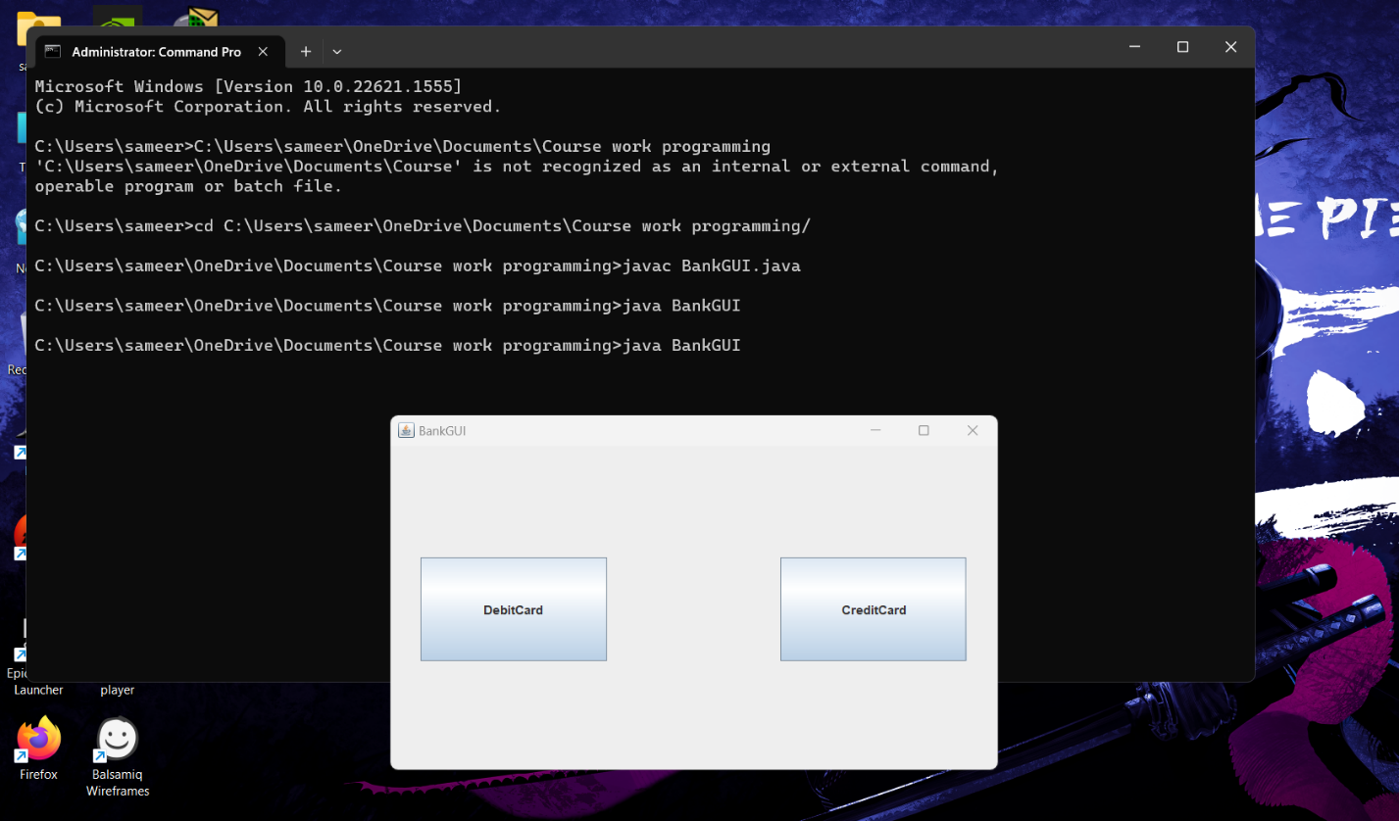

**Figure 18: Running the program through command prompt**

6. Error detection and correction

## 6.1 Syntax error and correction

The data type String starts with small ‘s’ which causes error

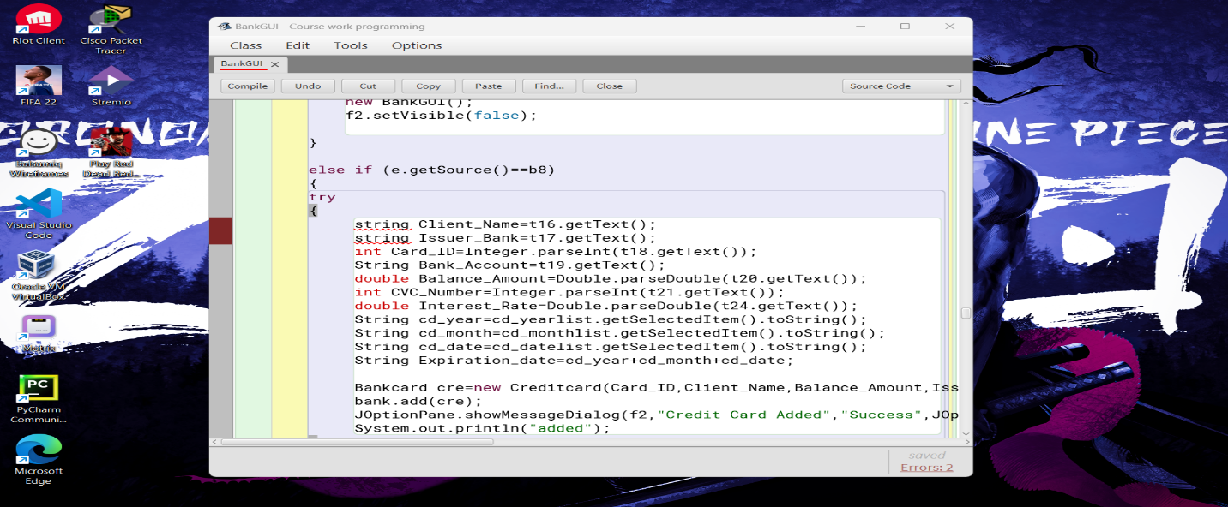

**Figure 19: Syntax error**

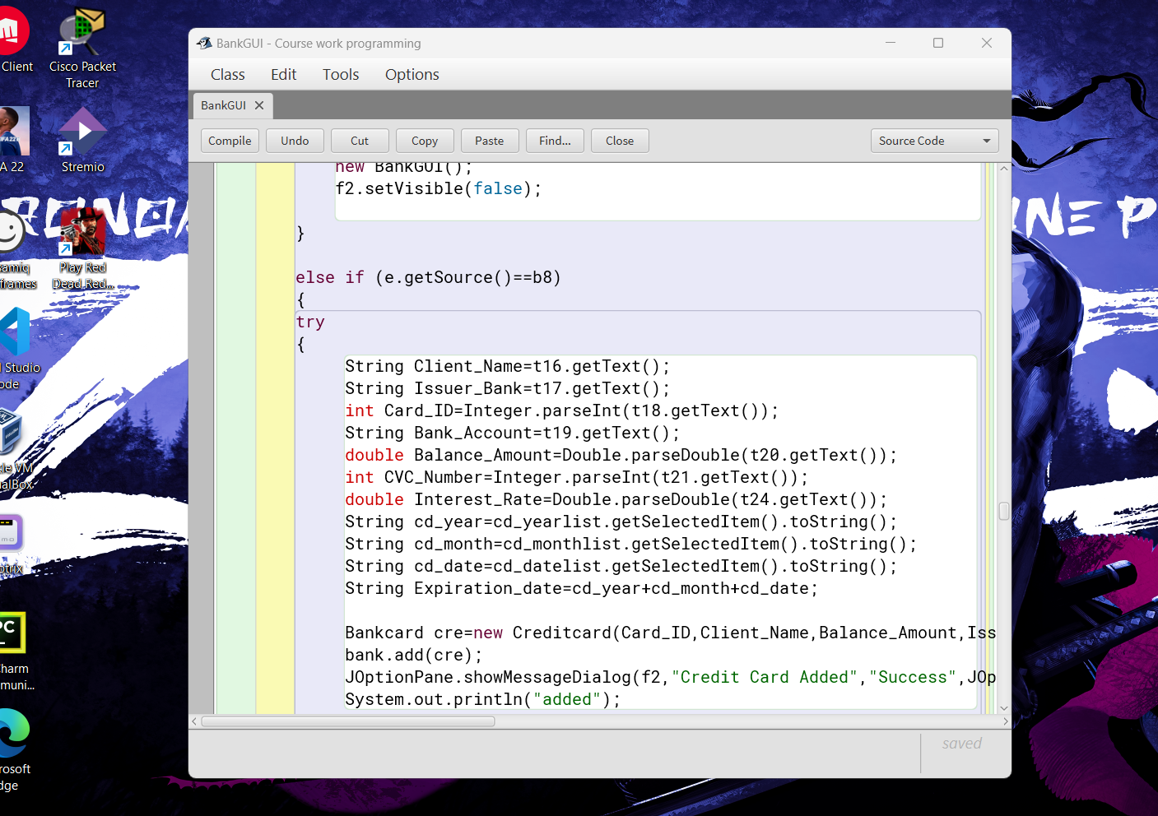

**Figure 20: Syntax error corrected**

## 6.2 Semantic error and correction

The parameter are not in the position as in the parent class

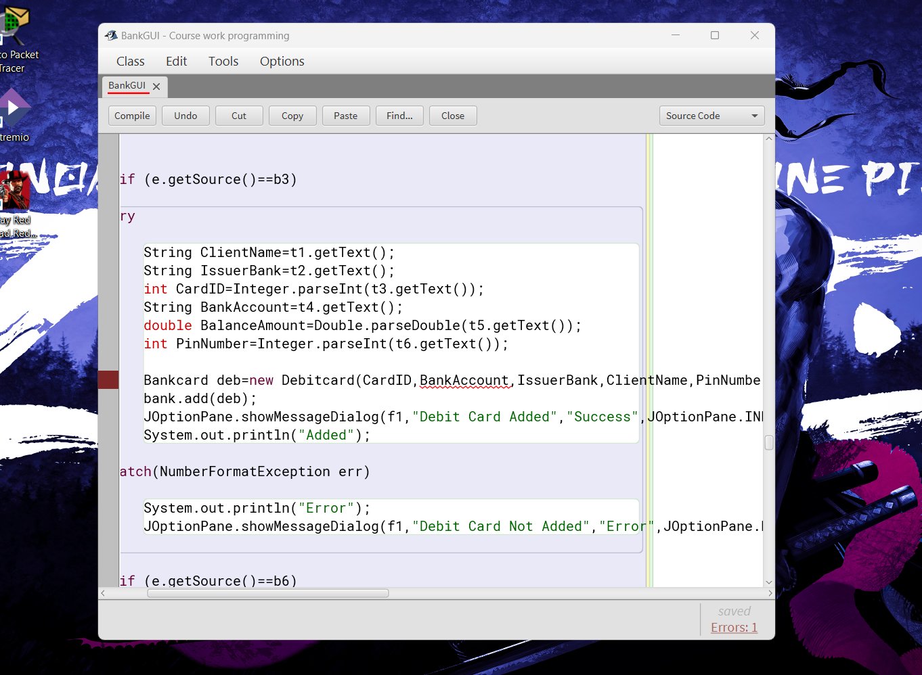

**Figure 21: Semantic Error**

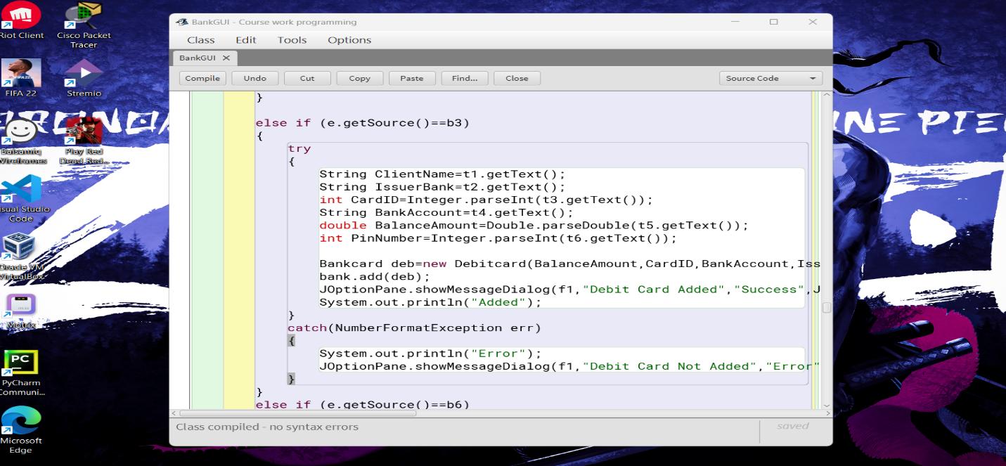

**Figure 22: Semantic error correction**

## 6.3 Logical error and correction

In the error the if condition is wrong since according to question the card id should be equal to added card id also the pin number should be equal to the added pin number.

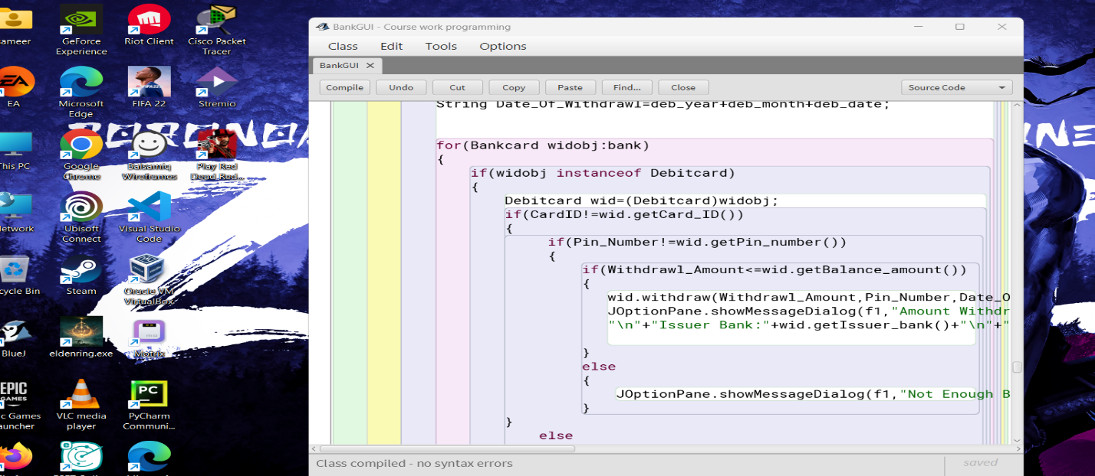

**Figure 23: Logical error**

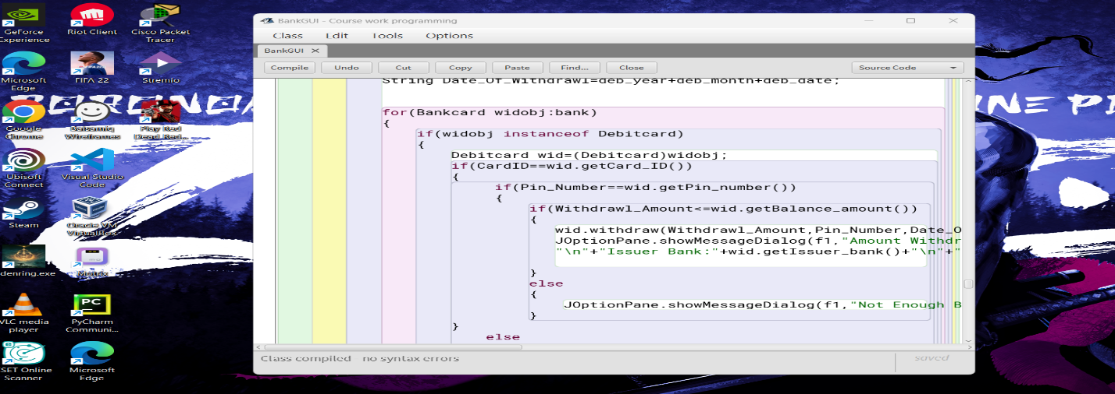

**Figure 24: Logical error correction**

# 

# 7. Conclusion

In conclusion, I have successfully developed Java-based Graphical User Interfaces (GUIs) for debit and credit cards that offer a number of essential capabilities for managing the users accounts. My debit card GUI allows users to add values and make cash withdrawals, whereas my credit card GUI allows users to add values, set credit limits, and cancel the credit card.

The credit card GUI makes it simple for consumers to control their credit limit, which is crucial for good money management. Users may prevent going over their budget by setting a credit limit, which helps them stay out of debt. A further level of control is offered via the credit card cancellation option, enabling consumers to close their accounts when needed.

Users may effortlessly add money to their accounts using the debit card GUI, which is a critical function for managing their finances. Users have more freedom and control over their finances thanks to the ability to withdraw money as needed.

Overall, my Java GUIs for debit and credit cards offer a full range of functions for managing user accounts. The user-friendly, secure interfaces offer a productive way to manage finances.

# 8. Appendix

import java.awt.*;

import javax.swing.*;

import java.awt.event.*;

import java.util.ArrayList;

public class BankGUI extends Frame implements ActionListener

{

JFrame f;

JFrame f1;

JFrame f2;

JPanel p;

JPanel p1;

JPanel p2;

JLabel l1,l2,l3,l4,l5,l6,l7,l8,l9,l10,l11,l12,l13,l14,l15,l16,l17,l18,l19,l20,l21,l22,l23,l24,l25,l26,l27,l28,l29;

JTextField t1,t2,t3,t4,t5,t6,t7,t8,t9,t10,t11,t12,t13,t14,t15,t16,t17,t18,t19,t20,t21,t22,t23,t24,t25,t26,t27,t28,t29;

JButton b1,b2,b3,b4,b5,b6,b7,b8,b9,b10,b11,b12,b13,b14,b15;

JComboBox yearlist,monthlist,datelist,cd_yearlist,cd_datelist,cd_monthlist;

ArrayList<Bankcard> bank=new ArrayList<Bankcard>();

public BankGUI()

{

//creating frame and panel

f=new JFrame();

p=new JPanel();

f.add(p);

//creating button

b1=new JButton("DebitCard");

b1.setBounds(29,108,180,100);

p.add(b1);

b2=new JButton("CreditCard");

b2.setBounds(376,108,180,100);

p.add(b2);

//eventlistener registering

b1.addActionListener(this);

b2.addActionListener(this);

f.setLayout(null);

p.setLayout(null);

p.setSize(600,350);

f.setSize(600,350);

f.setVisible(true);

p.setVisible(true);

f.setTitle("BankGUI");

f.setDefaultCloseOperation(f.EXIT_ON_CLOSE);

}

public void DebitCard()

{

//creating frame and panel

f1=new JFrame();

p1=new JPanel();

f1.add(p1);

//creating label

l10=new JLabel("Add to Debit Card");

l10.setBounds(72,10,257,36);

l10.setFont(new Font("Arial",Font.BOLD,20));

p1.add(l10);

l1=new JLabel("Client Name");

l1.setBounds(15,70,80,25);

p1.add(l1);

l2=new JLabel("Issuer Bank");

l2.setBounds(15,115,80,25);

p1.add(l2);

l3=new JLabel("Card_ID");

l3.setBounds(15,160,80,25);

p1.add(l3);

l4=new JLabel("Bank Account");

l4.setBounds(15,196,120,25);

p1.add(l4);

l5=new JLabel("Balance Amount");

l5.setBounds(15,242,120,25);

p1.add(l5);

l6=new JLabel("Pin Number");

l6.setBounds(15,295,120,25);

p1.add(l6);

l11=new JLabel("Withdraw");

l11.setBounds(709,10,166,36);

l11.setFont(new Font("Arial",Font.BOLD,20));

p1.add(l11);

l7=new JLabel("Card ID");

l7.setBounds(629,70,80,25);

p1.add(l7);

l8=new JLabel("Withdrwal Amount");

l8.setBounds(629,115,125,25);

p1.add(l8);

l9=new JLabel("Date of withdrawl");

l9.setBounds(629,160,135,25);

p1.add(l9);

l12=new JLabel("Pin Number");

l12.setBounds(629,205,80,25);

p1.add(l12);

//creating text field

t1=new JTextField();

t1.setBounds(134,58,180,32);

p1.add(t1);

t2=new JTextField();

t2.setBounds(134,104,180,32);

p1.add(t2);

t3=new JTextField();

t3.setBounds(134,150,180,32);

p1.add(t3);

t4=new JTextField();

t4.setBounds(134,196,180,32);

p1.add(t4);

t5=new JTextField();

t5.setBounds(134,242,180,32);

p1.add(t5);

t6=new JTextField();

t6.setBounds(134,288,180,32);

p1.add(t6);

t7=new JTextField();

t7.setBounds(735,64,180,32);

p1.add(t7);

t8=new JTextField();

t8.setBounds(735,112,180,32);

p1.add(t8);

t9=new JTextField();

t9.setBounds(735,208,180,32);

p1.add(t9);

//creating combobox

String[]year={"2023"};

yearlist=new JComboBox(year);

yearlist.setBounds(735,160,63,25);

p1.add(yearlist);

String[]month={"Jan","Feb","March","April","May","June","July","Aug","Sept","Oct","Nov","Dec"};

monthlist=new JComboBox(month);

monthlist.setBounds(808,160,63,25);

p1.add(monthlist);

String[]date={"1","2","3","4","5","6","7","8","9","10","11","12","13","14","15","16","17","18","19","20","21","22","23","24","25","26","27","28","29","30","31","32"};

datelist= new JComboBox(date);

datelist.setBounds(881,160,63,25);

p1.add(datelist);

b3=new JButton("Add to Debit Card");

b3.setBounds(63,418,180,32);

p1.add(b3);

b4=new JButton("Display");

b4.setBounds(306,418,180,32);

p1.add(b4);

b5=new JButton("Withdraw");

b5.setBounds(540,418,180,32);

p1.add(b5);

b6=new JButton("Clear");

b6.setBounds(795,418,180,32);

p1.add(b6);

b7=new JButton("Go Back");

b7.setBounds(411,196,140,32);

p1.add(b7);

b5.addActionListener(this);

b4.addActionListener(this);

b6.addActionListener(this);

b3.addActionListener(this);

b7.addActionListener(this);

p1.setLayout(null);

f1.setSize(1080,550);

f1.setVisible(true);

f1.setTitle("DebitGUI");

f1.setDefaultCloseOperation(f.EXIT_ON_CLOSE);

}

public void CreditCard()

{

f2=new JFrame();

p2=new JPanel();

f2.add(p2);

l25=new JLabel("Add to Credit Card");

l25.setBounds(72,10,257,36);

l25.setFont(new Font("Arial",Font.BOLD,20));

p2.add(l25);

l15=new JLabel("Client Name");

l15.setBounds(15,70,80,25);

p2.add(l15);

l16=new JLabel("Issuer Bank");

l16.setBounds(15,115,80,25);

p2.add(l16);

l17=new JLabel("Card_ID");

l17.setBounds(15,160,80,25);

p2.add(l17);

l18=new JLabel("Bank Account");

l18.setBounds(15,196,120,25);

p2.add(l18);

l19=new JLabel("Balance Amount");

l19.setBounds(15,242,120,25);

p2.add(l19);

l20=new JLabel("CVC Number");

l20.setBounds(15,295,120,25);

p2.add(l20);

l21=new JLabel("Set Credit Limit");

l21.setBounds(839,10,166,36);

l21.setFont(new Font("Arial",Font.BOLD,20));

p2.add(l21);

l22=new JLabel("Card ID");

l22.setBounds(781,70,80,25);

p2.add(l22);

l23=new JLabel("Credit Limit");

l23.setBounds(781,108,125,25);

p2.add(l23);

l24=new JLabel("Grace Period");

l24.setBounds(781,146,135,25);

p2.add(l24);

l25=new JLabel("Interest Rate");

l25.setBounds(15,340,80,25);

p2.add(l25);

l26=new JLabel("Expiration Date");

l26.setBounds(15,385,120,25);

p2.add(l26);

l27=new JLabel("Cancel Credit Card");

l27.setBounds(436,10,207,36);

l27.setFont(new Font("Arial",Font.BOLD,20));

p2.add(l27);

l28=new JLabel("Card ID");

l28.setBounds(430,65,80,25);

p2.add(l28);

t15=new JTextField();

t15.setBounds(505,58,180,32);

p2.add(t15);

t16=new JTextField();

t16.setBounds(134,58,180,32);

p2.add(t16);

t17=new JTextField();

t17.setBounds(134,104,180,32);

p2.add(t17);

t18=new JTextField();

t18.setBounds(134,150,180,32);

p2.add(t18);

t19=new JTextField();

t19.setBounds(134,196,180,32);

p2.add(t19);

t20=new JTextField();

t20.setBounds(134,242,180,32);

p2.add(t20);

t21=new JTextField();

t21.setBounds(134,288,180,32);

p2.add(t21);

t22=new JTextField();

t22.setBounds(865,63,180,32);

p2.add(t22);

t23=new JTextField();

t23.setBounds(865,101,180,32);

p2.add(t23);

t24=new JTextField();

t24.setBounds(134,334,180,32);

p2.add(t24);

t25=new JTextField();

t25.setBounds(865,139,180,32);

p2.add(t25);

String[]year={"2023"};

cd_yearlist=new JComboBox(year);

cd_yearlist.setBounds(126,380,60,25);

p2.add(cd_yearlist);

String[]month={"Jan","Feb","March","April","May","June","July","Aug","Sept","Oct","Nov","Dec"};

cd_monthlist=new JComboBox(month);

cd_monthlist.setBounds(217,380,60,25);

p2.add(cd_monthlist);

String[]date={"1","2","3","4","5","6","7","8","9","10","11","12","13","14","15","16","17","18","19","20","21","22","23","24","25","26","27","28","29","30","31","32"};

cd_datelist= new JComboBox(date);

cd_datelist.setBounds(308,380,60,25);

p2.add(cd_datelist);

b8=new JButton("Add to Credit Card");

b8.setBounds(58,457,180,32);

p2.add(b8);

b9=new JButton("Display");

b9.setBounds(289,457,180,32);

p2.add(b9);

b10=new JButton("Go Back");

b10.setBounds(755,364,180,32);

p2.add(b10);

b11=new JButton("Cancel");

b11.setBounds(386,139,140,32);

p2.add(b11);

b12=new JButton("Set");

b12.setBounds(885,191,60,42);

p2.add(b12);

b13=new JButton("Clear");

b13.setBounds(573,139,140,32);

p2.add(b13);

b8.addActionListener(this);

b13.addActionListener(this);

b10.addActionListener(this);

b12.addActionListener(this);

b11.addActionListener(this);

b9.addActionListener(this);

p2.setLayout(null);

f2.setSize(1080,550);

f2.setVisible(true);

f2.setTitle("CreditGUI");

f2.setDefaultCloseOperation(f.EXIT_ON_CLOSE);

}

public void actionPerformed(ActionEvent e)

{

if (e.getSource()==b1)

{

DebitCard();

f.setVisible(false);

f1.setVisible(true);

}

else if(e.getSource()==b2)

{

CreditCard();

f.setVisible(false);

f2.setVisible(true);

}

else if(e.getSource()==b7)

{

new BankGUI();

f1.setVisible(false);

}

else if(e.getSource()==b10)

{

new BankGUI();

f2.setVisible(false);

}

else if (e.getSource()==b8)

{

try

{

String Client_Name=t16.getText();

String Issuer_Bank=t17.getText();

int Card_ID=Integer.parseInt(t18.getText());

String Bank_Account=t19.getText();

double Balance_Amount=Double.parseDouble(t20.getText());

int CVC_Number=Integer.parseInt(t21.getText());

double Interest_Rate=Double.parseDouble(t24.getText());

String cd_year=cd_yearlist.getSelectedItem().toString();

String cd_month=cd_monthlist.getSelectedItem().toString();

String cd_date=cd_datelist.getSelectedItem().toString();

String Expiration_date=cd_year+cd_month+cd_date;

Bankcard cre=new Creditcard(Card_ID,Client_Name,Balance_Amount,Issuer_Bank,Bank_Account,CVC_Number,Interest_Rate,Expiration_date);

bank.add(cre);

JOptionPane.showMessageDialog(f2,"Credit Card Added","Success",JOptionPane.INFORMATION_MESSAGE);

System.out.println("added");

}

catch(NumberFormatException err)

{

System.out.println("Error");

JOptionPane.showMessageDialog(f2,"Credit Card Not Added","Error",JOptionPane.ERROR_MESSAGE);

}

}

else if (e.getSource()==b3)

{

try

{

String ClientName=t1.getText();

String IssuerBank=t2.getText();

int CardID=Integer.parseInt(t3.getText());

String BankAccount=t4.getText();

double BalanceAmount=Double.parseDouble(t5.getText());

int PinNumber=Integer.parseInt(t6.getText());

Bankcard deb=new Debitcard(BalanceAmount,CardID,BankAccount,IssuerBank,ClientName,PinNumber);

bank.add(deb);

JOptionPane.showMessageDialog(f1,"Debit Card Added","Success",JOptionPane.INFORMATION_MESSAGE);

System.out.println("Added");

}

catch(NumberFormatException err)

{

System.out.println("Error");

JOptionPane.showMessageDialog(f1,"Debit Card Not Added","Error",JOptionPane.ERROR_MESSAGE);

}

}

else if (e.getSource()==b6)

{

t1.setText("");

t2.setText("");

t3.setText("");

t4.setText("");

t5.setText("");

t6.setText("");

t7.setText("");

t8.setText("");

t9.setText("");

}

else if(e.getSource()==b13)

{

t15.setText("");

t16.setText("");

t17.setText("");

t18.setText("");

t19.setText("");

t20.setText("");

t21.setText("");

t22.setText("");

t23.setText("");

t24.setText("");

t25.setText("");

}

else if(e.getSource()==b5)

{

try

{

int CardID=Integer.parseInt(t7.getText());

int Withdrawl_Amount=Integer.parseInt(t8.getText());

int Pin_Number=Integer.parseInt(t9.getText());

String deb_year=yearlist.getSelectedItem().toString();

String deb_month=monthlist.getSelectedItem().toString();

String deb_date=datelist.getSelectedItem().toString();

String Date_Of_Withdrawl=deb_year+deb_month+deb_date;

for(Bankcard widobj:bank)

{

if(widobj instanceof Debitcard)

{

Debitcard wid=(Debitcard)widobj;

if(CardID==wid.getCard_ID())

{

if(Pin_Number==wid.getPin_number())

{

if(Withdrawl_Amount<=wid.getBalance_amount())

{

wid.withdraw(Withdrawl_Amount,Pin_Number,Date_Of_Withdrawl);

JOptionPane.showMessageDialog(f1,"Amount Withdrawn"+"\n"+"CardID:"+wid.getCard_ID()+"\n"+"Client Name:"+wid.getClient_name()+

"\n"+"Issuer Bank:"+wid.getIssuer_bank()+"\n"+"Balance Amount:"+wid.getBalance_amount()+"\n"+"Withdrawn Amount:"+wid.getWithdrawl_amount(),"Success",JOptionPane.INFORMATION_MESSAGE);

}

else

{

JOptionPane.showMessageDialog(f1,"Not Enough Balance","Error",JOptionPane.ERROR_MESSAGE);

}

}

else

{

JOptionPane.showMessageDialog(f1,"Incorrect Pin_Number","Error",JOptionPane.ERROR_MESSAGE);

}

}

else

{

JOptionPane.showMessageDialog(f1,"Incorrect Card_ID","Error",JOptionPane.ERROR_MESSAGE);

}

}

}

}

catch(NumberFormatException err)

{

System.out.println("error");

}

}

else if(e.getSource()==b12)

{

try{

int CardID=Integer.parseInt(t22.getText());

int CreditLimit=Integer.parseInt(t23.getText());

int GracePeriod=Integer.parseInt(t25.getText());

for(Bankcard objset:bank)

{

if(objset instanceof Creditcard)

{

Creditcard cd_set=(Creditcard)objset;

if(CardID==cd_set.getCard_ID())

{

if(CreditLimit <= 2.5 * cd_set.getBalance_amount())

{

JOptionPane.showMessageDialog(f2,"Credit Limit Set","Success",JOptionPane.INFORMATION_MESSAGE);

cd_set.setCredit_limit(CreditLimit,GracePeriod);

}

else

{

JOptionPane.showMessageDialog(f2,"Balance exceeded","Fail",JOptionPane.INFORMATION_MESSAGE);

}

}

else

{

JOptionPane.showMessageDialog(f2,"Incorrect Card ID","Error",JOptionPane.ERROR_MESSAGE);

}

}

}

}

catch(NumberFormatException err)

{

System.out.println("Error");

}

}

else if(e.getSource()==b11)

{

try

{

int CardID=Integer.parseInt(t22.getText());

for(Bankcard objcancel:bank)

{

if(objcancel instanceof Creditcard)

{

Creditcard cd_cancel=(Creditcard)objcancel;

if(CardID==cd_cancel.getCard_ID())

{

cd_cancel.cancelCreditCard();

JOptionPane.showMessageDialog(f2,"Credit Card Cancelled","Success",JOptionPane.INFORMATION_MESSAGE);

System.out.println("canceled");

}

else

{

JOptionPane.showMessageDialog(f2,"Incorrect Card ID","Error",JOptionPane.ERROR_MESSAGE);

}

}

}

}

catch(NumberFormatException err)

{

System.out.println("error");

}

}

else if(e.getSource()==b9)

{

for(Bankcard objdisplay:bank)

{

if(objdisplay instanceof Creditcard)

{

Creditcard cd_dis=(Creditcard)objdisplay;

cd_dis.display();

}

}

}

else if(e.getSource()==b4)

{

for(Bankcard objdisplay:bank)

{

if(objdisplay instanceof Debitcard)

{

Debitcard deb_dis=(Debitcard)objdisplay;

deb_dis.display();

}

}

}

}

public static void main(String[]args)

{

new BankGUI();

}

}